ITA0435 – STATISTICS WITH R PROGRAMMING FOR VISUALIZATION
NAME : R.SABARISH
REG NO: 192324092
1) R Programming Structures
1. Write an R program to take a numeric vector and print its length, type (typeof), andclass.
PROGRAM:
# 1. Program to print length, type (typeof), and class of a numeric vector

num_vector <- c(10, 20, 30, 40, 50)

cat("Length of vector:", length(num_vector), "\n")
cat("Type of vector (typeof):", typeof(num_vector), "\n")
cat("Class of vector:", class(num_vector), "\n")
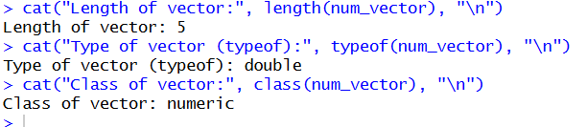
OUTPUT :
2. Write an R program to create a list containing a vector, matrix, and data frame, thendisplay the structure using str()
PROGRAM:
my_vector <- c(1, 2, 3, 4)

my_matrix <- matrix(c(5, 6, 7, 8), nrow = 2)

my_dataframe <- data.frame(
Name = c("John", "Alice"),
Age = c(22, 24)
)

my_list <- list(
Vector = my_vector,
Matrix = my_matrix,
DataFrame = my_dataframe
)

cat("\nStructure of the list:\n")
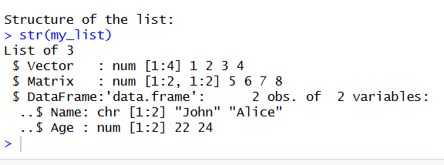
str(my_list)

2) for() Loop
3. Write an R program using for loop to print numbers from 1 to 10 and their squares
PROGRAM :
# Print numbers from 1 to 10 and their squares

for (i in 1:10) {
cat("Number:", i, " Square:", i^2, "\n")
}
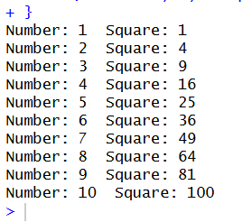

4. Write an R program using for loop to find the sum of even numbers from1 to 50
#4. R Program to Find the Sum of Even Numbers from 1 to 50

# Initialize sum variable
sum_even <- 0

# Loop from 1 to 50
for (i in 1:50) {
if (i %% 2 == 0) { # Check if number is even
sum_even <- sum_even + i
}
}

# Print result
cat("Sum of even numbers from 1 to 50 is:", sum_even)
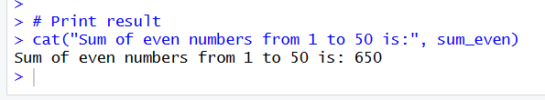
3) while() Loop
5. Write an R program using while loop to print numbers from 10 down to 1.
PROGRAM :
#R Program to Print Numbers from 10 Down to 1 Using while() Loop
# Initialize variable
i <- 10

# While loop
while (i >= 1) {
print(i)
i <- i - 1
}
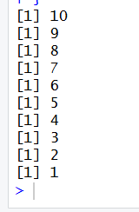
6. Write an R program using while loop to find the factorial of a number n.
PROGRAM:
#6.R Program to Print Numbers from 10 Down to 1 Using while() Loop
# Input number
n <- 5

# Initialize variables
fact <- 1
i <- 1

# While loop
while (i <= n) {
fact <- fact * i
i <- i + 1
}

# Print result
cat("Factorial of", n, "is:", fact)
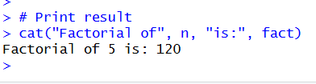

4) Control Statements (break, next)
7. Write an R program that prints numbers 1 to 20 but skips multiples of 3 using next.
PROGRAM :
#R program that prints numbers 1 to 20 but skips multiples of 3 using next
# Loop from 1 to 20
for (i in 1:20) {

if (i %% 3 == 0) {
next # Skip multiples of 3
}

print(i)
}
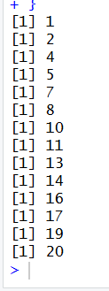
8. Write an R program that scans a vector and stops when it finds a negative number using break.
# R program that scans a vector and stops when it finds a negative number using break.
# Create a vector
numbers <- c(10, 25, 8, 15, -5, 20, 30)

# Scan vector
for (num in numbers) {

if (num < 0) {
cat("Negative number found:", num, "\n")
break # Stop loop
}

print(num)
}
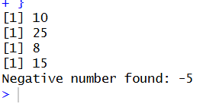

5) Looping Over Non-Vector Sets (lists)
9. Create a list of 5 items and use a loop to print each element
#Create a list of 5 items and use a loop to print each element
# Create a list with 5 items
my_list <- list(
100,
"R Programming",
TRUE,
c(1, 2, 3),
list(a = 10, b = 20)
)
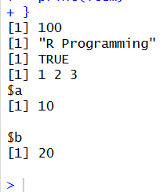

10. Create a list containing vectors of different lengths and use a loop to print thelength of each item.
PROGRAM :
#Create a list containing vectors of different lengths and use a loop to print thelength of each item.
# Create list containing vectors of different lengths
vector_list <- list(
c(10, 20, 30),
c(5, 15),
c(1, 2, 3, 4, 5),
c(100),
c(7, 14, 21, 28)
)

# Loop through the list
for (i in seq_along(vector_list)) {
cat("Length of item", i, ":", length(vector_list[[i]]), "\n")
}
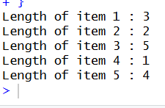

6) If-Else
11. Write an R program using if-else to check whether a number is positive, negative, or zero.
PROGRAM :
#R Program to Check Whether a Number is Positive, Negative, or Zero
# Input number
num <- 10 # Change this value to test

# Check condition
if (num > 0) {
cat("The number is Positive\n")
} else if (num < 0) {
cat("The number is Negative\n")
} else {
cat("The number is Zero\n")
}
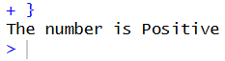
12. Write an R program using if-else to assign grades: A (≥90), B (≥75), C(≥60), elseFail.
#R Program to Assign Grades Using if-else
# Input marks
marks <- 85 # Change value to test

# Grade assignment
if (marks >= 90) {
cat("Grade: A\n")
} else if (marks >= 75) {
cat("Grade: B\n")
} else if (marks >= 60) {
cat("Grade: C\n")
} else {
cat("Grade: Fail\n")
}
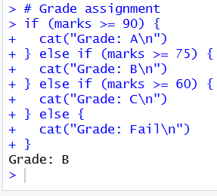
7) Arithmetic Operators
13. Write an R program that reads two numbers and prints + , − , × , ÷ , %%, %/%results.
# 13. Arithmetic Operations on Two Numbers

num1 <- 20
num2 <- 6

cat("Addition (+):", num1 + num2, "\n")
cat("Subtraction (-):", num1 - num2, "\n")
cat("Multiplication (*):", num1 * num2, "\n")
cat("Division (/):", num1 / num2, "\n")
cat("Modulus (%%):", num1 %% num2, "\n")
cat("Integer Division (%/%):", num1 %/% num2, "\n")
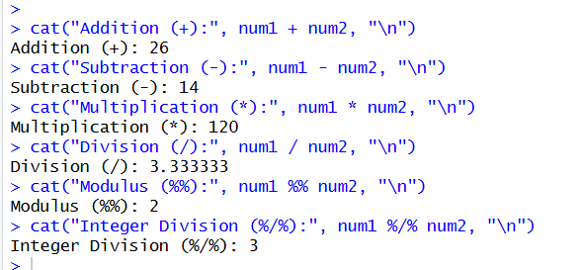
14. Write an R program to calculate simple interest using arithmetic operators.

# 14. Simple Interest Calculation

principal <- 1000
rate <- 5
time <- 2

simple_interest <- (principal * rate * time) / 100

cat("Simple Interest is:", simple_interest, "\n")
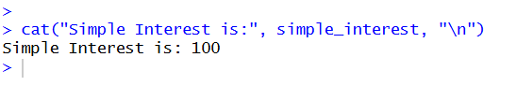
# 15. Check whether a number lies between 10 and 50

num <- 35

if (num >= 10 & num <= 50) {
cat("Using &: Number lies between 10 and 50\n")
} else {
cat("Using &: Number does NOT lie between 10 and 50\n")
}

if (num < 10 | num > 50) {
cat("Using |: Number is outside the range 10 to 50\n")
} else {
cat("Using |: Number is inside the range 10 to 50\n")
}
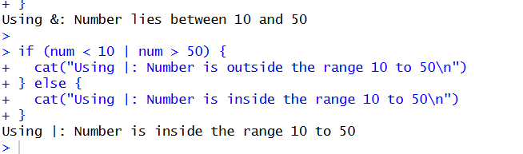

16. Write an R program to filter values in a vector that satisfy: x > 5 ANDx is even.
# 16. Filter values in a vector that satisfy condition (greater than 10 and less than 50)

x <- c(5, 12, 25, 60, 45, 8, 30)

filtered_values <- x[x > 10 & x < 50]

cat("Filtered values (between 10 and 50):\n")
print(filtered_values)
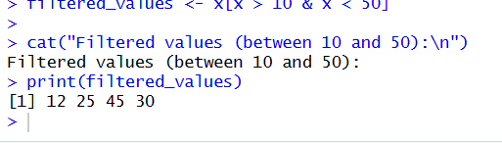

9) Default Values for Arguments
17. Write a function power(x, p=2) that returns x^p; call it with and without p.
# 17. Function with Default Argument (Power Function)

power <- function(x, p = 2) {
return(x^p)
}

# Calling function without p (default p = 2)
cat("Power with default p:", power(5), "\n")

# Calling function with custom p
cat("Power with given p:", power(5, 3), "\n")
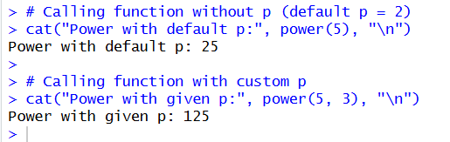

18. Write a function discount(price, rate=0.10) that returns final price after discount.
PROGRAM:
# 18. Function with Default Discount Rate

discount <- function(price, rate = 0.10) {
final_price <- price - (price * rate)
return(final_price)
}

# Calling function without rate (default 10%)
cat("Final price with default discount:", discount(1000), "\n")

# Calling function with custom rate
cat("Final price with 20% discount:", discount(1000, 0.20), "\n")
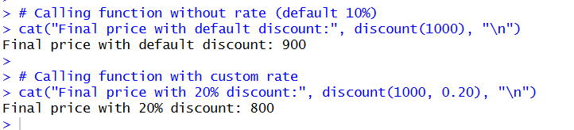

10) Return Values (implicit vs explicit return)
19. Write a function that returns the largest of two numbers (use explicit return())
# 19. Function to return the largest of two numbers (Explicit return)

largest_number <- function(a, b) {
if (a > b) {
return(a)
} else {
return(b)
}
}

cat("Largest number is:", largest_number(10, 25), "\n")
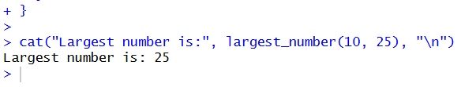
20. Write a function that returns the sum of a vector without using return() (implicit return).
# 20. Function to return sum of a vector (Implicit return)

sum_vector <- function(x) {
sum(x) # Last evaluated expression is automatically returned
}

numbers <- c(5, 10, 15, 20)
cat("Sum of vector is:", sum_vector(numbers), "\n")
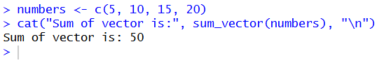

11) Deciding Whether to Explicitly call return()
21. Write a function that checks if a number is prime and uses return(FALSE) earlywhen divisible
PROGRAM :
# 21. Function to check whether a number is prime
# Uses explicit return(FALSE) for early exit

is_prime <- function(n) {

if (n <= 1) {
return(FALSE)
}

for (i in 2:(n - 1)) {
if (n %% i == 0) {
return(FALSE) # Early return if divisible
}
}

return(TRUE) # If no divisor found
}

cat("Is 7 prime?", is_prime(7), "\n")
cat("Is 8 prime?", is_prime(8), "\n")
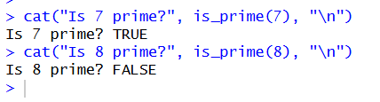

22. Write a function that calculates average and returns "Invalid" using return() if thevector is empty.
# 22. Function to calculate average
# Returns "Invalid" if vector is empty

calculate_average <- function(x) {

if (length(x) == 0) {
return("Invalid") # Explicit return for empty vector
}

avg <- sum(x) / length(x)
return(avg)
}

cat("Average:", calculate_average(c(10, 20, 30)), "\n")
cat("Average of empty vector:", calculate_average(c()), "\n")
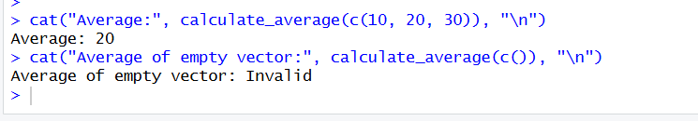

12) Returning Complex Objects
23. Write a function that returns mean and standard deviation as a list.
# 23. Function to return mean and standard deviation as a list

calculate_stats <- function(x) {

mean_value <- mean(x)
sd_value <- sd(x)

return(list(
Mean = mean_value,
Standard_Deviation = sd_value
))
}

result1 <- calculate_stats(c(10, 20, 30, 40, 50))
print(result1)
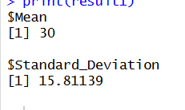
24. Write a function that returns min, max, range as a named list.
# 24. Function to return min, max, and range as a named list

range_stats <- function(x) {

min_value <- min(x)
max_value <- max(x)
range_value <- max_value - min_value

return(list(
Minimum = min_value,
Maximum = max_value,
Range = range_value
))
}

result2 <- range_stats(c(5, 15, 25, 35, 45))
print(result2)
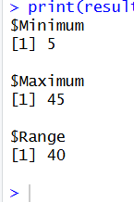
13) Functions are Objects (First-class)
25. Assign a function to a variable and call it (e.g., f <- function(x) x*2).
# 25. Assign a function to a variable and call it

f <- function(x) {
x * 2
}

cat("Result of f(5):", f(5), "\n")
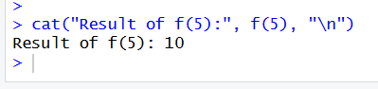

26. Write a function that accepts another function as an argument and applies it toavector.
# 26. Function that accepts another function as argument
# and applies it to a vector

apply_function <- function(func, vec) {
return(func(vec))
}

# Example function to pass
square_function <- function(x) {
x^2
}

numbers <- c(1, 2, 3, 4, 5)

result <- apply_function(square_function, numbers)

cat("Result after applying function:\n")
print(result)

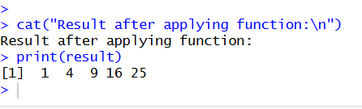

14) No Pointers in R
27. Write a program showing pass-by-value behavior: modify a vector inside afunction and show original remains unchanged.
# 27. Demonstrating Pass-by-Value Behavior in R

modify_vector <- function(v) {
v[1] <- 999 # Modify inside function
print("Modified vector inside function:")
print(v)
}

original_vector <- c(10, 20, 30, 40)

modify_vector(original_vector)

cat("Original vector outside function:\n")
print(original_vector)
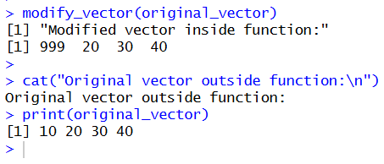

28. Write a program using <<- to modify a global variable inside a functionanddisplay the change
# 28. Using <<- to Modify a Global Variable Inside a Function

global_var <- 100

modify_global <- function() {
global_var <<- 500 # Super assignment operator
}

cat("Before modification:", global_var, "\n")

modify_global()

cat("After modification:", global_var, "\n")
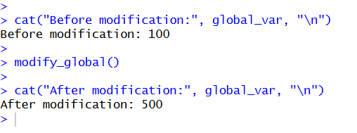

15) Recursion
29. Write a recursive function to compute factorial(n)

# 29. Recursive function to compute factorial

factorial_recursive <- function(n) {

if (n == 0 || n == 1) {
return(1) # Base condition
}

return(n * factorial_recursive(n - 1))
}

cat("Factorial of 5 is:", factorial_recursive(5), "\n")
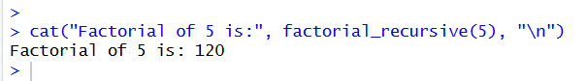

30. Write a recursive function to compute Fibonacci(n)
# 30. Recursive function to compute Fibonacci

fibonacci_recursive <- function(n) {

if (n == 0) {
return(0) # Base condition
}

if (n == 1) {
return(1) # Base condition
}

return(fibonacci_recursive(n - 1) + fibonacci_recursive(n - 2))
}

cat("Fibonacci of 6 is:", fibonacci_recursive(6), "\n")
